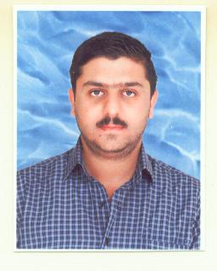
Curriculum Vitae
Personal Information:
Name: Mustafa Sa’adi Sadeq
Nationality: Iraqi
Sex: Male
Material statues: Married
D.O.B: 29/03/1980
Address: Baghdad, Iraq Hay AL Gazaliya
Mobile : +9647901301993 / +9647513012147
E-mail: mustafa.sadi293@gmail.com

Languages:
Arabic (mother language)
English (Excellent understanding, speaking and writing)
Turkish (very good understanding, speaking and writing)

Computer Skills:
Microsoft Office (Word, Excel, power point and outlook)

Use of office machinery:
Computers, networks, scanners, photocopy machine and camera

Certification and education:
BSc Turkish language - College of Languages
Baghdad University / 2005 -2006

Skills:
Team work spirit
Communication skills
Reporting skills
Ability to work under pressure
Ability to communicate with different kind of people from different backgrounds and cultures
Ability and flexibility of movement in different areas of Baghdad and all governorates in Iraq
Experiences:

a-Working with AMAR U.S.A Foundation As a Center Manager of AMAR Community Engagement Project Since
1st of April 2018 till now .

- 10 years of experience with different departments in Zain Company for Telecommunications 2006-2016

Supervisor at call center department from the mid of 2008-2016

My work was dedicated to follow up the attendance, time sheets, pay slip and overtime bonuses, leaves and many related issues of staff under supervision.

Call center agent at call center department 2006 -2008

My responsibilities was to answer phone calls and enquires also to solve customer problems, this period strengthened my knowledge in dealing with different kinds of customers.

Providing support to the sales department as a data entry for 3 months, my work was data entry and information management.

C-Project supervisor and translator

Taj Al Mlook Company for General Contracting and Trade Agencies from 2005

Specific tasks were following up with the working teams and the governmental Ministries and authorities including all correspondences and communications.

- Accountant and project manager assistant

Remal Al-Rafidain / Construction Company 2004

My responsibility was monitoring and following up minor civil works of different projects .

Reference:

Ali Sadeq Hameed
Acting Director of Customer Care Department
Zain Company for Telecommunications
07901900808

Ghalib Jawad Al-Abadi
General Manager
Taj Al Mlook Company
07901943881

Hayder Akram Salman
Project manager
Remal Al Rafidain / Construction Company
07814271940

